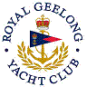 | Royal Geelong Yacht Club Inc.  Est 1859
Trophy Deed of Gift.

Trophy: | Y.W. Diamond Geelong Fleet Trophy
Presented by:
Date: | 1966
For: | Y.W. Diamond Championship Aggregate
Remarks / Revisions

